**NO SQL 3**

**Creating Table:**

db.createCollection(**"Restaurant"**);

db.restaurants.insertMany([

{name:"Meghna Foods",town:"Jayanagar", cuisine: "Indian", score: 8, address: { zipcode: "10001", street: "Jayanagar"}},

{ name: "Empire", town: "MG Road", cuisine: "Indian", score: 7, address: { zipcode: "10100", street: "MG Road" } },

{ name: "Chinese WOK", town: "Indiranagar", cuisine: "Chinese", score: 12, address: { zipcode: "20000", street: "Indiranagar"}},

{ name: "Kyotos", town: "Majestic", cuisine: "Japanese", score: 9, address: { zipcode: "10300", street: "Majestic" } },

{ name: "WOW Momos", town: "Malleshwaram", cuisine: "Indian", score: 5, address: { zipcode: "10400", street: "Malleshwaram" }}])

**QUERIES**

1) db.Restraunt.find()

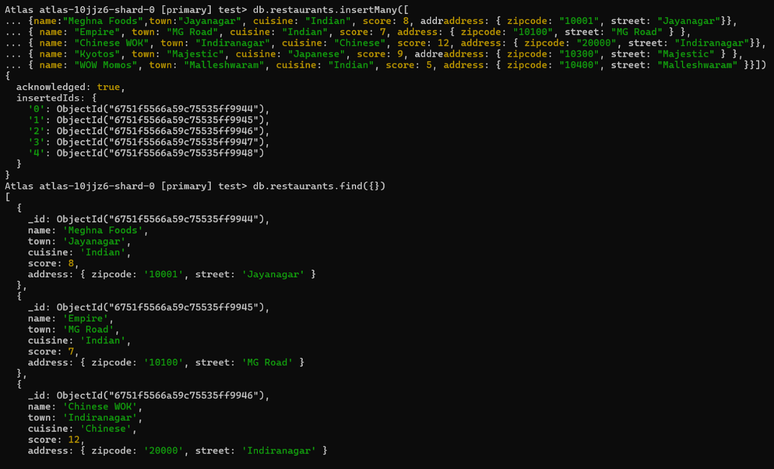

2) db.Restraunt.find().sort({ "name": -1 });

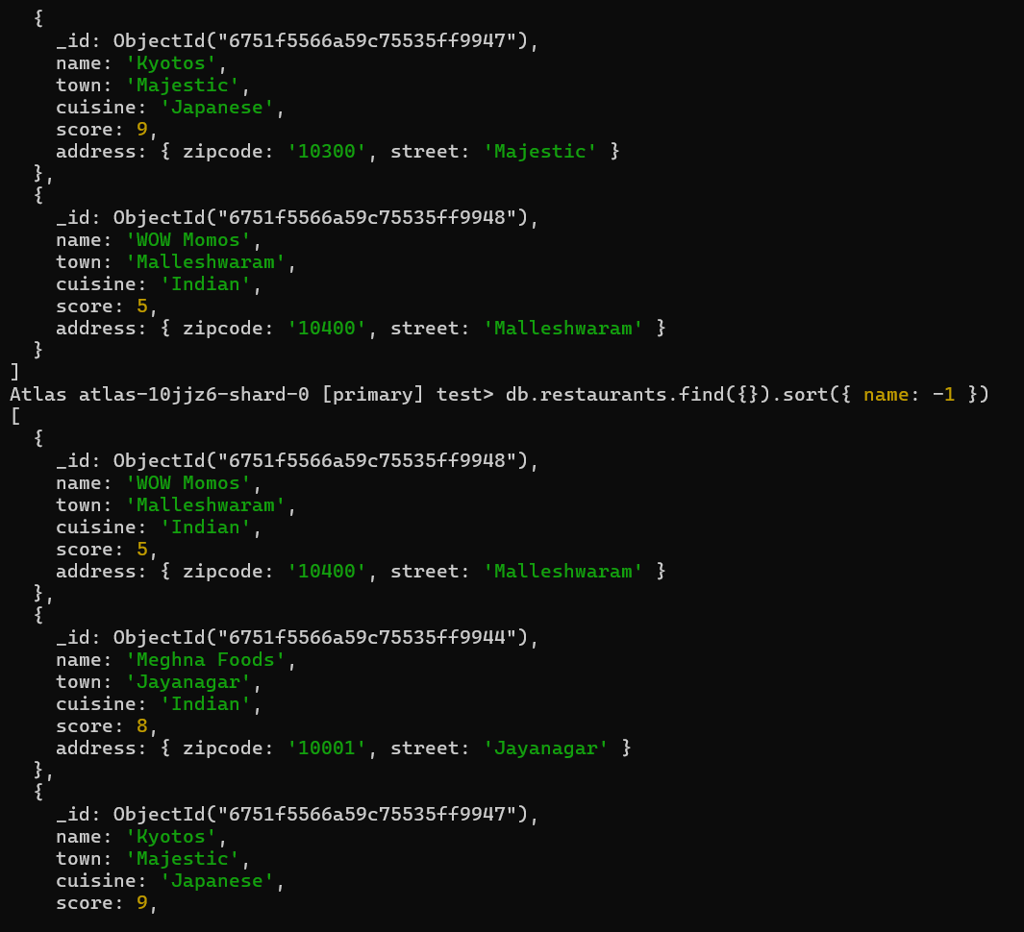

3) db.Restraunt.find(

{ "grades.score": { $lte: 10 } },

{ _id: 1, name: 1, town: 1, cuisine: 1, restaurant_id: 1 }

);

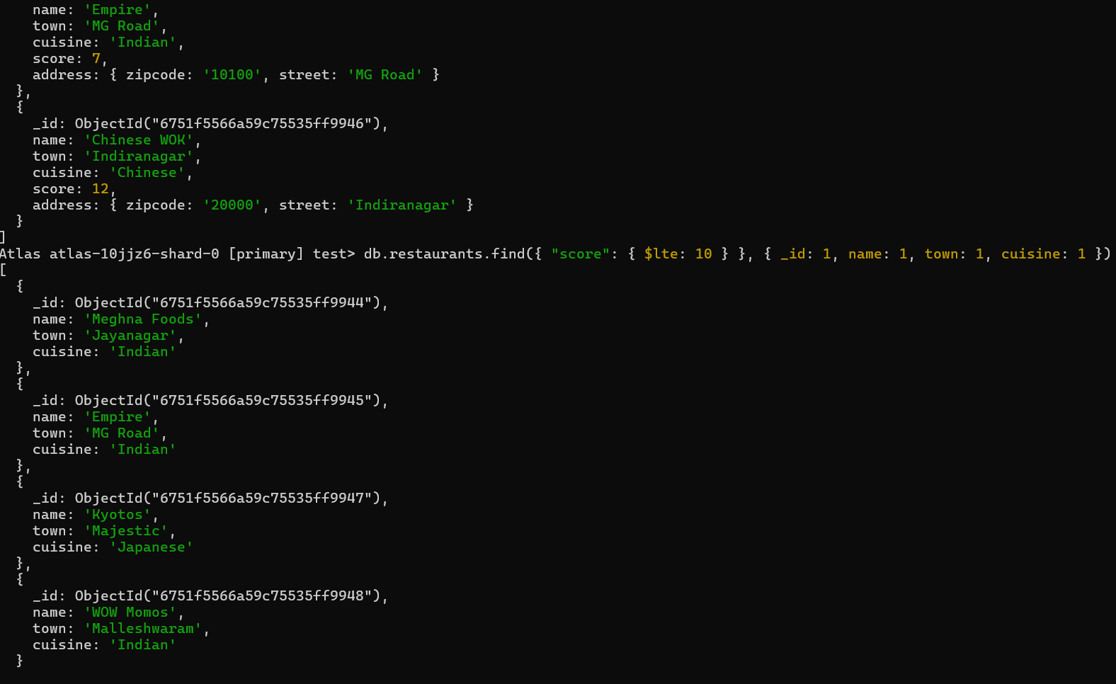

4)db.restaurants.aggregate([ { $group: { _id: "$name", average_score: { $avg: "$score" }}}])

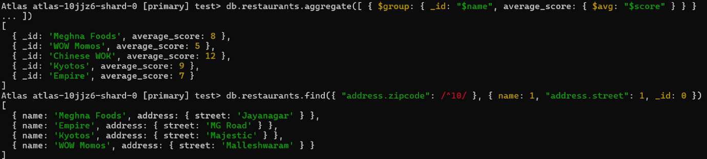

5)db.restaurants.find({ "address.zipcode": /^10/ }, { name: 1, "address.street": 1, _id: 0 })

